MHA IT Service Description

Residents PC
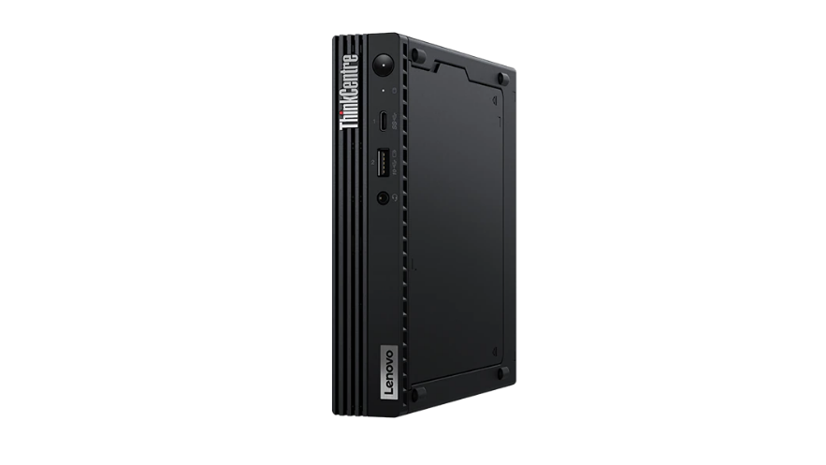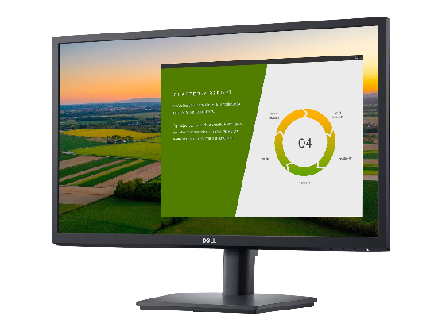

Service Overview
A compact Lenovo ThinkCentre M70q Gen 2 Tiny (Intel) desktop PC along with 22” monitor, keyboard, mouse, webcam, and headset. There is also the optional choice of a printer for use by residents and their families in our care homes.

Eligibility
This service is available to all care homes and retirement living.

Service Features
- Open Office (word processor, spreadsheet & presentation applications)
- Webcam and headset for video calling
- Compact PC design to minimise visual impact and space required, PC also comes with a mount so can be attached underneath a desk to hide the PC
- Optional MFP printer allowing residents to print, copy & scan documents

Device Specification - PC
Model | ThinkCentre M70q Gen 2 Tiny (Intel)
Form factor | SFF Desktop PC
Operating system | Windows 10
Size | 179mm x 36.5mm x 182.9mm
Weight | 1.32kg
Replacement Cycle | 3 Years
Initial cost to MHA | £486.55 (ex. VAT)

Device Specification – Monitor
Model | Dell P2222H
Screen type | LED-backlit
Screen size | 22 inches
Dimensions (WxDxH) | 48.726 cm x 17.957 cm x 48.199 cm - with stand
Weight | 4.8 kg
Other features | Height & tilt adjustments
Initial cost to MHA | £118.99 (ex. VAT)

Device Specifications – Printer
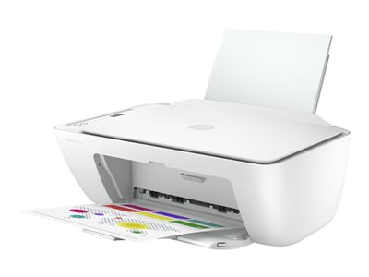

Model | HP Deskjet 2710e All-in-One - multifunction printer - colour
Dimensions (W x D x H) | 42.5 cm x 30.4 cm x 15.4 cm
Features | Print, Scan & Copy
Key Features | HP Instant Ink Available (Site management will need to register for this)
 | Copying speeds of up to 6 pages per minute
 | Print speeds of up to 7.5 pages per minute
 | Print Resolution 4800 x 1200 dpi (colour)

Financials
 | Cost | Warranty
Installation by staff on site, support provided remotely only by MHA IT. | £38.99 (ex. VAT) | 1 Year

Consumables Costs
HP 305XL - High Yield - pigmented black - original - ink cartridge | 240 (£0.06 per page) | £13.99 (ex. VAT)
HP 305XL - High Yield - colour (cyan, magenta, yellow) - original - ink cartridge | 200 (£0.07 per page) | £12.99 (ex. VAT)

Please note – It is the responsibility of the care home/retirement living site to purchase replaceable consumables for the residents’ machine. The printer will arrive with an initial set of ink cartridges, but further replacements will not be supplied by IT. However IT can facilitate with the process by providing advice & recommendations.

Device specifications – Peripherals
Device | Features | Cost
V7 Essentials - headset | - USB 2.0  - Stereo Sound  - Wired  - Buttons for volume & microphone on/mute  - Over both ears | £10.99 ex. VAT
Logitech HD Webcam C270 | - USB 2.0  - 1.5m Wired  - 720p HD video calls | £24.99 ex. VAT

Total Initial Costings
Device | Cost
PC | £486.55
Monitor | £118.99
Headset | £10.99
Webcam | £24.99
Printer | £38.99
Total | £680.51 (ex. VAT)

Request Process
To request this service please complete the online form on the Intranet with your choice of
device.

Funding
The cost of each device is shown for information only to allow homes to make the most
cost-effective choice for their needs. MHA IT will fully fund the initial cost of the equipment.

Additional or replacement accessories (ink cartridges, headset, webcam, mouse & keyboard) must be funded and procured by the user’s department. These can be obtained from MHA’s usual office supplies vendors. If a device (PC, Monitor & Printer) is lost, stolen or damaged, MHA IT will fund the cost of replacement according to policy TEC-009.

Support
This service is fully supported by the IT Service Desk who will assist with any faults or
questions you have.

Notes
- Ensure you have plenty of space, for the computer, monitor, keyboard and mouse. Additional space will also be required if the optional printer is selected.
- This PC setup will require at a minimum 2 power sockets, 1 for the PC, 1 for the monitor and 1 additional socket if a printer is requested.
- Ideally all resident’s PC’s need to have a wired connection to ensure the best possible connection to the network, if you already have an existing residents PC then you should already have this data point. If you do not then these PC’s do come with built in wireless but where necessary the site may need to fund the installation of data cabling

